测试beacon列表

|  |  |  |  |  |
| --- | --- | --- | --- | --- |
|  | Sensoro | Black April | White April | Drop |
| A | 0117C5397841 | 78A5044137B5 | B4994C8AC15E | 1E:09:97:2C:45:33 |
| B | 0117C538BE39 | 78A504415DF9 | B4994C8AC15A | 34:17:47:B3:BE:F2 |
| C | 0117C5332818 | 78A504415A26 | B4994C8AC7D4 | 3B:91:83:A3:05:03 |
| D | 0117C51A74DB(无) | 78A504413A23 | B4994C8AB2D9 | 31:84:A8:BD:76:67 |
| E |  | 78:A5:04:41:2A:C1 | B4:99:4C:8A:D1:EF |  |
| F |  | 78:A5:04:41:3A:32 | B4:99:4C:8A:AE:9F |  |
| G |  | 78:A5:04:41:68:A3 | DO:39:72:E8:05:69 |  |
| H |  | 78:A5:04:41:17:41 | DO:39:72:E8:06:94 |  |

矩形环走实验

矩形环走实验示意图

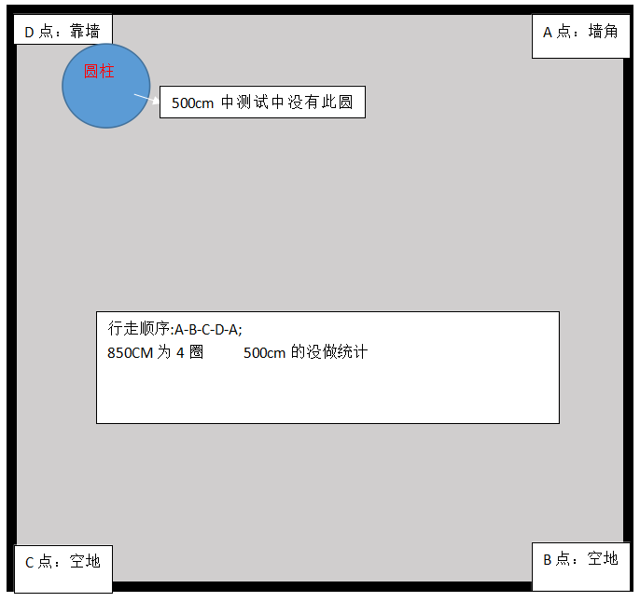

九点测试实验：

